**Ecological processes drive the effects of host resistance diversity on pathogen spread and susceptible host fitness**

Jack Common1*, David Walker-Sünderhauf2, Stineke van Houte1, Edze R. Westra1*

1ESI and CEC, Biosciences, University of Exeter, Cornwall Campus, Penryn TR10 9EZ, UK

2European Centre for Environment and Human Health, University of Exeter Medical School, ESI, Cornwall Campus, Penryn TR10 9FE, UK

* Corresponding authors

Email: [jc860@exeter.ac.uk](mailto:jc860@exeter.ac.uk)

Email: [E.R.Westra@exeter.ac.uk](mailto:E.R.Westra@exeter.ac.uk)

**SHORT TITLE:** Ecological effects of diversity in host-pathogen systems

**KEYWORDS:** CRISPR-Cas, *Pseudomonas aeruginosa*, phage, experimental evolution, host-pathogen, evolutionary emergence

**AUTHOR CONTRIBUTIONS**: JC conducted experiments and analyses. DWS and SVH designed plasmids and cloning methods. ERW conceived of and designed the study. JC wrote the manuscript, DWS, SVH and ERW provided critical revisions.

**DATA ACCESSIBILITY**: All raw data and R code associated with this this study are publicly available at github.com/JackCommon/Common_etal_2019_host_diversity

# ****Abstract****

Diversity in host resistance often associates with reduced pathogen spread. This may result from ecological and evolutionary processes, likely with feedback between them. Theory and experiments on bacteria-phage interactions have shown that genetic diversity of the bacterial adaptive immune system can limit phage evolution to overcome resistance. Using the CRISPR-Cas bacterial immune system and lytic phage, we engineered a host-pathogen system with a non-overlapping genetic architecture of infectivity. With this model system, we explored how diversity impacts the spread of phage when they can overcome a resistance allele, how immune diversity affects the evolution of the phage to increase its host range, and if there was feedback between these processes. We show that increasing diversity benefits susceptible bacteria by limiting the spread of the phage, likely through a dilution effect. Our data suggest that ecological processes are the key drivers behind the effects of diversity in host-pathogen systems.

# Author Summary

Diversity in immune systems can slow down or even prevent disease (pathogens) from spreading. We already know that diversity matters, for example in protecting crops and endangered wild populations from pathogens. However, it’s not entirely clear what drives this effect of diversity. It could be due to how diversity “dilutes” hosts, making them harder to infect; it could be because new pathogens are less likely to evolve when diversity is high; and it could be a combination of both. To help answer why diversity matters for disease spread, we did an experiment with bacteria and their viruses. We found that diversity matters because the bacteria a virus can infect gets more diluted, which slows and eventually stops the virus. This is important because it gives us a better idea of how to limit diseases in already threatened populations.

# Introduction

Genetic diversity is a key determinant of the ecology and evolution of host-pathogen systems. Various studies of wild organisms have shown that genetic diversity within a host species often affects pathogen prevalence. The importance of diversity for disease prevalence in wild populations has been observed in numerous species, for example: cheetahs (1); Italian agile frogs (2); crimson rosella parrots (3); inbred black-footed ferret populations (8); inbred California sea lions (9); young island populations of deer mice (10); and Galapagos hawks (11). The importance of diversity for limiting disease in agricultural contexts has long been recognised (12), for example in rice (13) and hybridising populations of honeybees (14). In laboratory environments, more genetically diverse populations of *Daphnia magna* are more resistant to parasites (15), an effect that depends on the genetic architecture of resistance (16). In microbial systems, *Pseudomonas aeruginosa* PA14 and *Streptococcus thermophilus* with diverse immunity alleles were shown to be more resistant against lytic bacteriophage (17, 18). Two recent meta-analyses have shown that host diversity is a robust defence against pathogens both in agricultural (Reiss & Drinkwater 2018) and natural populations (Ekroth et al 2019).

The suggested reasons for the effect of host diversity on pathogen spread can be broadly divided into ecological and evolutionary effects. The ecological effect of diversity may manifest through a dilution effect (19, 20). In terms of within-species immune diversity, increasing the number of resistant or low-quality hosts decreases the fraction of susceptible hosts. This can reduce contact rates between free-living pathogens and susceptible hosts, which in turn limits the basic reproduction number of the pathogen (*R*0) (21-23). There is much observational support for the role of a dilution effect in multi-species host-pathogen systems (reviewed in Civitello, Cohen (20)), and some experimental work has suggested that dilution of susceptible hosts can limit pathogen spread in single host species systems (24, 25). Evolutionary effects of diversity many manifest through limitation of the evolutionary emergence of novel pathogen genotypes (26, 27), potentially because the supply of novel pathogen mutations depends on the prevalence of susceptible hosts (28-30). The evolutionary and ecological effects of host diversity are likely to depend on one another, as the basic reproductive value of a pathogen will influence its ability to evolve to overcome host resistance (29). Further, because increasing host diversity dilutes susceptible hosts, pathogens may reach smaller population sizes and generate fewer novel variants on which selection can act. Simultaneously, increasing host diversity can increase selection for novel variants. These two effects can maximise evolutionary emergence at intermediate host diversity (31, 32).

The interaction between lytic bacteriophage (phage) and the bacterial CRISPR-Cas (Clustered Regularly Interspaced Short Palindromic Repeats; CRISPR-associated) immune system represents a tractable model system to study the evolutionary ecology of infectious diseases, including the role of host diversity (17, 31, 33). CRISPR-Cas immune systems can incorporate short DNA fragments (spacers) of about 30 base pairs derived from the phage genome into CRISPR loci on the host genome (34). Processed CRISPR transcripts guide Cas immune complexes to identify and cleave the invading phage genome, preventing successful re-infections (35-38). In turn, phage can evolve to overcome CRISPR immunity by point mutation in the sequence targeted by the spacer (protospacer) or in the protospacer-adjacent motif (PAM), which flanks the protospacer and functions in self/non-self discrimination (39-42). Phage evolution to overcome CRISPR immunity can lead to CRISPR-phage coevolution (43-46). However, CRISPR loci in both natural and experimental populations can be highly diverse (43, 44, 47, 48), due to different bacteria in the population acquiring different spacers (33). Diversity has important implications for the coevolutionary interaction, as CRISPR diversity can provide increased resistance by limiting the ability of phage to acquire the mutations needed to overcome CRISPR resistance (43). Phage mutation is limited by mutation supply (49-51), and full phage infectivity requires mutations in all the protospacers targeted by the host CRISPR array. This becomes more difficult as individual-and population-level CRISPR diversity increases (50, 52), and can drive rapid phage extinction (17, 18, 31).

Apart from this evolutionary effect, theory predicts that even if a phage mutant evolved that can overcome one CRISPR resistance allele in the population, its ability to amplify will be reduced in a more diverse host population (21). The resulting smaller phage population sizes are in turn predicted to reduce the ability of the phage to evolve to overcome other CRISPR resistance alleles in the population (29, 31). However, these predictions remain untested. We therefore set out to explicitly test the ecological role of host diversity and its knock-on evolutionary effects using the bacteria *Pseudomonas aeruginosa* and its lytic phage DMS3vir. To focus our experiments on ecology and provide a clearer link with existing theory, we generated a precise matching allele architecture of host-pathogen specificity (21, 53, 54) using the host’s CRISPR system and phage adaptation. then

# Results

To explore how population-level immune diversity would influence the population dynamics and evolution of an escape phage and its susceptible host genotype, we set up an experiment where we mixed 1-, 3-, 6-, 12- and 24-clones, and inoculated each treatment with an escape phage infecting only one of the clones (**Figures S1 & S2**). The susceptible clone (i.e. the one that could be infected by the escape phage) always carried a *lacZ* reporter gene, so we could follow its population dynamics and competitive performance during the experiment. *P. aeruginosa ∆pilA*, which only resists phage infection via surface receptor modification, was included in each treatment to provide a benchmark against which the dynamics and performance of the entire CRISPR population could be measured.We also included 1- and 24-clone treatments inoculated with ancestral phage to which the whole bacterial population was resistant, which served as a control (17). We then monitored population dynamics and evolution of the phage, CRISPR clones and the susceptible clone over 3 days.

We hypothesised that if CRISPR allele diversity limits phage epidemics, then both phage density and survival would be negatively correlated with CRISPR allele diversity. Phage densities did decrease more rapidly as CRISPR diversity increased (*F*6,342 = 48.30, *p* < 2.2 x 10-16), phage population sizes decreased over the course of the experiment (regression of ln pfu ml­­-1 over dpi: *β* [95% CI] =-1.32 [-1.74, -0.94], *t*(2)344 = -6.40, *p* = 5.06 x 10-10), and phage declined more rapidly in more diverse treatments (interaction between CRISPR allele diversity and days post-infection: *F*6,314 = 24.10, *p* < 2.2 x 10-16; **Figure 1A & B**). This is consistent with a protective effect of CRISPR diversity. The ancestral phage controls show that phage titre over time in a monoclonal (and initially resistant) host population is statistically similar to that observed when an escape phage infects a monoclonal (but susceptible) population (**Figure 1B**), which is in line with previous data showing that CRISPR-resistant monocultures allow phage persistence due to rapid evolution of escape phages that overcome the CRISPR resistance allele (17). Interestingly, when we explored the model further, we found that ancestral phage titres were lower in the 24-clone population with compared to the same treatment with the pre-evolved escape phage (difference in ln pfu ml-1: *β* [95% CI]= -2.40 [-4.67, -0.33], *t*(2)342 = -2.25, *p* = 0.03; **Figure 1B**). This is consistent with a modest escape phage epidemic being able to establish by replicating on the susceptible fraction of the host population.

Next we hypothesised that if phage survival across our diversity treatments was related to phage evolution, the proportion of phage that evolved an expanded infectivity range would be negatively related to CRISPR allele diversity. Given that our experiment was designed such that the proportion of the host population resistant to the escape phage increased with CRISPR allele diversity, there would likely have been strong selection to acquire mutations in other protospacers and PAMs to infect other hosts in the population. The evolution of range expansion did depend on diversity (LR = 6.60, *p* = 0.01), but it was most likely in the 6-clone treatment, particularly at 3 days post-infection (dpi) (**Figure 2**). This is consistent with the idea that intermediate host diversity maximises evolutionary emergence (31, 32). Together, these data suggest that phage population dynamics are not directly related to evolutionary emergence in the context of different levels of CRISPR allele diversity.

Despite this, it does appear that phage survival in some treatments was promoted by evolutionary emergence of host shift, where infectivity on the original host is lost but phage evolved to infect a new host. This is a less likely event as it involves two mutations: back-mutation to the ancestral state at the original protospacer followed by mutation at the new protospacer, all while incurring the cost of loss of infectivity on the original host. This could therefore be expected if the initial escape mutation was costly (it may cause a deleterious loss-of-function), or if there was sufficient selection pressure from the diverse population (31). We observed phage in two replicates of the 24-clone treatment had evolved via host shift. Sequence data confirmed that single nucleotide polymorphisms (SNPs) in the PAM that conferred infectivity to the original host had been lost, and novel SNPs or deletions had emerged in protospacers that conferred infectivity to a new host present in the population (**Tables S4 & S5**). The original escape mutations are unlikely to have been costly as they are due to a SNP in the PAM sequence (**Tables S4 & S5**), so the observed host shift may have instead been driven by the selection pressure induced by high host CRISPR diversity. These data suggest that transient phage survival under conditions of high host CRISPR allele diversity was likely enabled by the evolutionary emergence of host shift.

Given that CRISPR allele diversity negatively affected phage persistence, we reasoned that this could also lead to enhanced fitness of the CRISPR population as a whole (17). We therefore hypothesised that the selection rate (55, 56) of resistant CRISPR clones would be positively related to CRISPR allele diversity. We did find that resistant CRISPR clones in all polyclonal CRISPR populations had higher selection rates compared to clonal populations during infection with escape phage (**Figure 3A**). However, within the polyclonal populations, we did not detect a relationship between diversity and selection rate when controlling for the effect of time (*F*4,113 = 1.73, *p* = 0.15; **Figure 3A; Figure S3A**). Selection rate also did not change notably over time (regression of selection rate over dpi: *β* [95% CI] =0.03 [-0.04, 0.11], *t*(2)118 = 0.94, *p* = 0.35; **Figure S3A**) even though phage densities decreased with time.

The absence of a detectable relationship between CRISPR allele diversity and the selection rate of resistant CRISPR clones may be because escape phage dynamics were dependent on the susceptible subpopulation. Consequently, we hypothesised that the selection rate of susceptible CRISPR clones would be positively related to CRISPR allele diversity. Consistent with this, we found that the selection rate of susceptible CRISPR clones in the 3- and 6-clone treatments were on average lower than resistant CRISPR clones (mean selection rate [95% CI]; 3-clone: -1.53 [-2.61, -0.45]; 6-clone: -0.99 [-2.07, -0.09]), and selection rates in the 12- and 24-clone treatments were higher than the 3- and 6-clone treatments (12-clone: 0.12 [-0.96, 1.21]; 24-clone: 0.15 [-0.93, 1.24]). There was also an increase in selection rate over time among polyclonal treatments (regression of selection rate over dpi: *β* [95% CI] =0.41 [0.03, 0.80], *t*(2)118 = 2.17, *p* = 0.03; **Figure S3B**), which parallels the decline in phage population sizes over time in the same treatments (regression of ln pfu ml­­-1 over dpi: *β* [95% CI] =-2.58 [-3.23, -1.84], *t*(2)114 = -7.64, *p* = 7.27 x 10-12). These data suggest that susceptible hosts are protected by population-level CRISPR allele diversity, and importantly, that this protection is mediated by a reduced ability of phage to replicate on increasingly dilute susceptible hosts (**Figure S4**).

# Discussion

Previous studies have shown that CRISPR allele diversity can limit the evolution of phage to overcome host resistance (17, 31). In those studies, bacterial populations were infected with ancestral phage that had not been previously exposed to resistant hosts. Here, we examined the consequences of CRISPR allele diversity once a phage has already evolved to overcome one of the CRISPR resistance alleles in the population. This tractable system enabled us to closely monitor how the level of CRISPR allele diversity influenced the population and evolutionary dynamics of the phage, as well as the evolutionary dynamics of the host.

These analyses show that phage population sizes were larger and persisted longer in less diverse host populations, which is consistent with previous studies (17). They also show that resistant CRISPR clones were generally unaffected population-level CRISPR allele diversity, while the competitive performance of susceptible CRISPR clones was much more closely related to diversity. The pattern we observed in the selection rate of susceptible CRISPR clones parallels those of the phage population dynamics. Phage populations were larger in treatments where the susceptible clone was less competitive, and over time phage populations declined while susceptible CRISPR clones became more competitive. Together, tissuggest thatedd. This dilution effect of host resistance allele diversity is an important factor in explaining why genetically diverse host populations often have reduced pathogen loads (19, 20, 57). In theory, these ecological effects can in turn shape the evolutionary dynamics of the bacteria-phage interaction, since smaller phage population sizes will decrease the mutation supply and hence the evolutionary potential of the phage (28-30). However, we did not observe this evolutionary effect. Instead, the likelihood that an individual phage evolved to expand its host range did not follow the gradient of CRISPR allele diversity in our experimental treatments. Rather, the evolution of phage host range expansion peaked at intermediate levels of CRISPR allele diversity, namely in the 6-clone treatment. probably Simultaneously, iin dynamic tension

Altogether our results suggest that the ecological impact of host diversity, namely a dilution effect reducing phage reproduction, is the main determinant of phage population size and persistence. While we did observe results consistent with the previously-described evolutionary effects of diversity, they are unrelated to phage and host population dynamics. Hence, it appears that the effect of host diversity is mediated primarily through ecological and not evolutionary processes.

We did find evidence for a limited role for evolutionary feedback into ecological dynamics in this system. The instances of phage evolving host shift in our most diverse treatment were possibly related to a small initial escape phage epidemic establishing on susceptible hosts, which allowed host shift to occur. Although host shift only led to transient phage survival in our experiment, the effect of a susceptible host fraction in the context of a diverse, mostly-resistant population may have implications for more complex host-pathogen systems. Host shift mutants could gain an advantage due to changes in host genotype composition, for example when able to migrate to more susceptible subpopulations; or due to changes in reproductive mode in response to environmental change (58).

In this study, we focussed on host populations where different CRISPR resistance genotypes were at equal starting frequencies, but natural communities are often composed of a few very common and many rare variants (59, 60). This likely matters for the observed dynamics, since the proportion of susceptible hosts has a large impact on the probability of evolutionary emergence of pathogens (31). Also, we focussed our analysis on the simple case where a diverse host population is infected by a clonal pathogen population. In nature, pathogen populations will frequently be genetically diverse as well (61, 62), and increased levels of pathogen diversity may affect the benefits of host diversity (63). Indeed, previous studies of CRISPR-phage interactions suggest that infection by two different phages can increase bacteria-phage coexistence compared to infections with a single phage (44, 45). The empirical system used in this study offers both a unique ability to link genotypes and phenotypes, as well as tight experimental control over the infectivity matrix of the host-phage interaction. These features will make it an ideal system for more detailed studies to understand how the composition of the host population and the relative diversity levels of the phage and host shape coevolutionary interactions.

# Materials & Methods

## Bacterial strains and phage

Evolution experiments were carried out using *Pseudomonas aeruginosa* UCBPP-PA14 (which has two CRISPR loci, CRISPR1 and CRISPR2), UCBPP-PA14 *∆pilA* (this strain lacks the pilus, which is the phage DMS3 receptor, and therefore displays surface-based resistance) and phage DMS3vir (64). We used *P. aeruginosa* UCBPP-PA14 *csy3::lacZ* (65), which carries an inactive CRISPR-Cas system, for phage amplification, and for top lawns in phage spot and plaque assays. *P. aeruginosa* PA14 *csy3::lacZ, Escherichia coli* DH5α(NEB), *E. coli* CC118 λpir (NEB), and *E. coli* MFD*pir* (66)were used for molecular cloning.

## Co-culture experiment

To control the levels of CRISPR diversity in our evolution experiments, we established a library of 24 *P. aeruginosa* PA14 clones each carrying a single spacer in CRISPR2 (bacteriophage-insensitive mutants; BIMs). We also independently evolved 24 phage clones that could infect each BIM (escape phage). To be able to monitor the population dynamics and relative fitness of individual bacterial clones within the mixed populations over the course of the co-culture experiment, we transformed 8 BIMs to carry a *lacZ* reporter gene. The *LacZ* gene encodes the β-galactosidase enzyme that hydrolyes X-gal, resulting in the production of a blue pigment.

We designed 5 treatments in which we manipulated the level of CRISPR spacer diversity, based on the BIM library: monocultures (1-clone), or polycultures consisting of 3, 6, 12 and 24 clones. For each of the polyclonal treatments, a single BIM carrying the *lacZ* reporter gene was included. From fresh overnight cultures of each BIM, we made mixes of equal proportion of each clone corresponding to the diversity treatments. To monitor the population dynamics and competitive performance of the CRISPR-resistant population as a whole, we also added PA14 *∆pilA* (surface mutant; SM, which is fully resistant to phage DMS3vir and has a distinct “smooth” colony morphology) to each mix in equal proportion to the CRISPR population. We then inoculated 6ml of M9m 1:100 from each mix. Approximately 1x106 pfu ml-1 of the escape phage targeting the labelled BIM were then added to each vial. We also established 1- and 24-clone treatments with ancestral phage as controls. Polyclonal treatments consisted of 8 biological replicates (*N*=8) to ensure that both BIMs and phage were equally represented across treatments, while the 1-clone treatments consisted of 24 biological replicates (*N*=24). Glass vials were incubated at 37˚C while shaking at 180rpm. At 1, 2, and 3 days-post infection (dpi), the sampling of the phage and bacterial culture was repeated as described. Cultures were transferred 1:100 to fresh media after sampling had been carried out. The experiment was terminated at 3 dpi.

Each day 180μl of culture was taken from each vial and phage was extracted using chloroform. Phage titres were determined by serially diluting extracted phage in 1x M9 salts, and then spotting 5μl of each dilution on a top lawn of *P. aeruginosa* PA14 *csy3::lacZ*, which was then incubated at 37˚C for 24hrs. Phage titres were calculated from this assay. The detection limit of phage spot assays is 102 pfu ml–1. To monitor bacterial densities, culture samples were serially diluted in 1x M9 salts, and then plated on LB agar + 40µg/ml X-gal + 0.1mM IPTG, and incubated for 48hrs at 37˚C. The density of SM, CRISPR and the labelled BIM was then calculated. SM were differentiated from CRISPR clones by their “smooth” colony morphology, and the labelled BIM was identified by the blue:white screen.

We assessed the competitive performance of the CRISPR relative to SM clones and the labelled BIM relative to non-labelled BIMs by calculating selection rate (*rn* = (ln [density strain A at tn/density strain A at tn-1] – ln[density strain B at tn/density strain B at tn-1])/day) (55, 56), which expresses competitive performance as the natural log of the relative change in density of one competitor against another. First, the relative fitness (*W*) calculation used in Westra *et al*. (2015) (48) is very sensitive to starting densities and hence becomes increasingly skewed at later timepoints. Applied to our data, it consequently produced impossibly high values of *W*.

## Phage evolution

We examined phage evolution during the experiment by sampling 12 individual plaques from each replicate that had detectable levels of phage from 1 to 3 dpi, which were amplified on PA14 *csy3::lacZ* overnight in LB, at 37˚C and shaking at 180rpm. Phage were extracted using chloroform, and then diluted 1000-fold. Samples of each phage were then applied on lawns of each of the 24 BIMs and WT PA14 *csy3::lacZ*. A successful infection was indicated by a clear lysis zone on the top lawn. Phage were classified according to whether they had expanded their infectivity range (could infect the original susceptible clone and a new clone in the BIM library). Of the phages that had undergone a host shift (lost infectivity to the original clone and could only infect a new clone), we confirmed their expanded infectivity range by sequencing the old and new protospacers on the evolved phage genome (SourceBioscience, UK). We also sequenced the relevant protospacers of the pre-evolved escape phage from the BIM-phage library and ancestral DMS3vir. Primers are given in Table S3.

## Statistical analyses

All statistical analyses were carried out in R v3.5.3 (69). The packages dplyr (70), tidyr (71) and magrittr (72) were used for data handling. Generalised linear mixed models (GLMMs) were used throughout, and replicate was treated as a random effect in all models. Days post-infection (dpi) was treated as a continuous variable and CRISPR allele diversity as a categorical variable. Model selection followed a nested approach, where full versus reduced models were compared using information criteria (73, 74), and the similarity between observed and predicted values. The overall statistical significance of the single and interaction effects of fixed effects (that is, treatment and dpi) was assed using ANOVA, which gives an *F*- and associated *p*-value. Simple Bayesian GLMMs from the MCMCglmm (75) package were used to analyse phage evolution. These models used a probit transformation (the inverse standard normal distribution of the probability) and a flat prior. The overall statistical significance of the single and additive effects of fixed effects in these models was assessed using Likelihood Ratio (LR) tests and their associated *p*-values using the VCVglmm package (76). Where possible, exact *p*-values are given, but R is unable to give exact values when *p* < 2.2 x 10­­-16. When phage titre was considered as the response variable, data was log-transformed to improve model fit. Credibility intervals around model coefficients and predictions were calculated to the 95%, 89% and 67% level to give the reader a clearer indication of effect size. The package ggplot2 (77) was used to generate figures. All R code used for analyses and figures is available at this manuscript’s GitHub page.

# Acknowledgements

We thank Meaghan Castledine for help constructing the pBAM1(Gm)_lacZ plasmid.

# Funding

JC acknowledges funding from the Biotechnology and Biological Sciences Research Council (bbsrc.ac.uk/) (BB/J014400/1 and BB/M009122/1). DWS acknowledges funding from the Medical Research Council (mrc.ukri.org) (MR/N013794/1). SVH acknowledges funding from the BBSRC (BB/R010781/1) and from the People Programme (Marie Curie Actions; ec.europa.eu/research/mariecurieactions/) of the European Union’s Horizon 2020 (REA grant agreement no. 660039). ERW acknowledges funding from the Natural Environment Research Council (nerc.ac.uk) (NE/M018350/1), the European Research Council (erc.europa.eu) (ERC-STG-2016-714478 – EVOIMMECH) and the BBSRC (BB/N017412/1).

# Figure captions

**Figure 1 A** Population dynamics of phage at different levels of CRISPR allele diversity in the host population (panels). Black lines show the phage density expressed as plaque-forming units (pfu) ml-1 in individual replicates at each day post-infection (x-axis). The limit of phage detection is 200 pfu ml-1. **B** Coefficients from a GLMM of the natural log of phage density (ln[pfu ml-1]), with CRISPR allele diversity treatment and days post-infection (dpi) as fixed effects. The intercept is the mean phage titre in the 1-clone treatment at 0 dpi. The *β* differences from the intercept are shown for the remaining levels of both fixed effects. The dotted line at zero indicates no difference from the intercept. Means are shown as white points with 67, 89% and 95% credibility intervals given in decreasing width.

**Figure 2** Estimated proportion of phage that had evolved to infect a second CRISPR clone in addition to the original CRISPR clone they were pre-evolved to infect at each day post-infection (panels; 1, 2, and 3 dpi) in each polyclonal CRISPR allele diversity treatment (x-axis; 3-, 6-, 12- and 24-clone treatments). Because these estimates are derived from a Bayesian GLMM, they are posterior modes - not means – and are shown as white points. Similarly, 67, 89 and 95% credibility intervals are highest probability density intervals, and are given in decreasing width around mode estimates.

**Figure 3** Selection rate of **A** resistant CRISPR clones relative to surface mutants and **B** the susceptible CRISPR clone relative to resistant CRISPR clones in the population for each CRISPR allele diversity treatment. Selection rate is the natural log of the relative change in density of one competitor against another. The dotted line at zero indicates no difference in density change i.e. the susceptible and resistant CRISPR clones are equally fit. Means are derived from a GLMM that statistically controls for the effect of time. Means are shown as white points with 67, 89 and 95% credibility intervals given in decreasing width.

# Figures

Figure 1

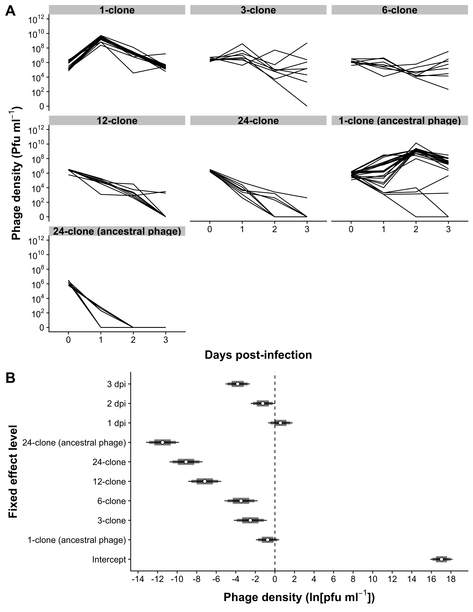

Figure 2

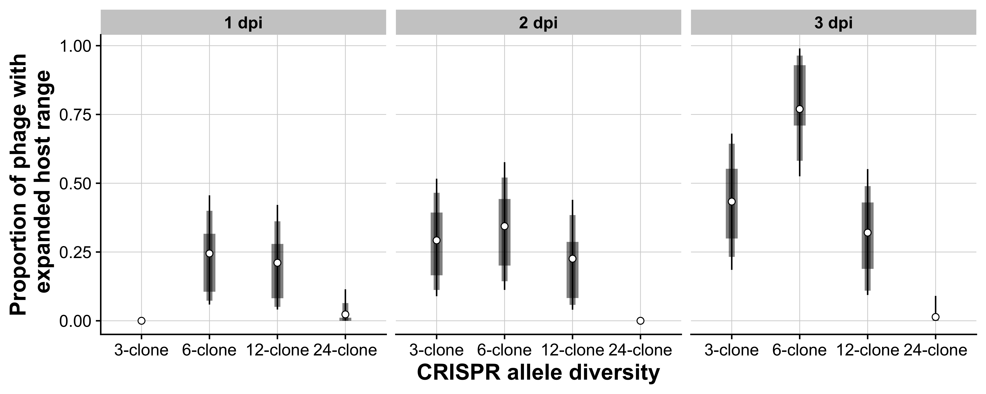

Figure 3

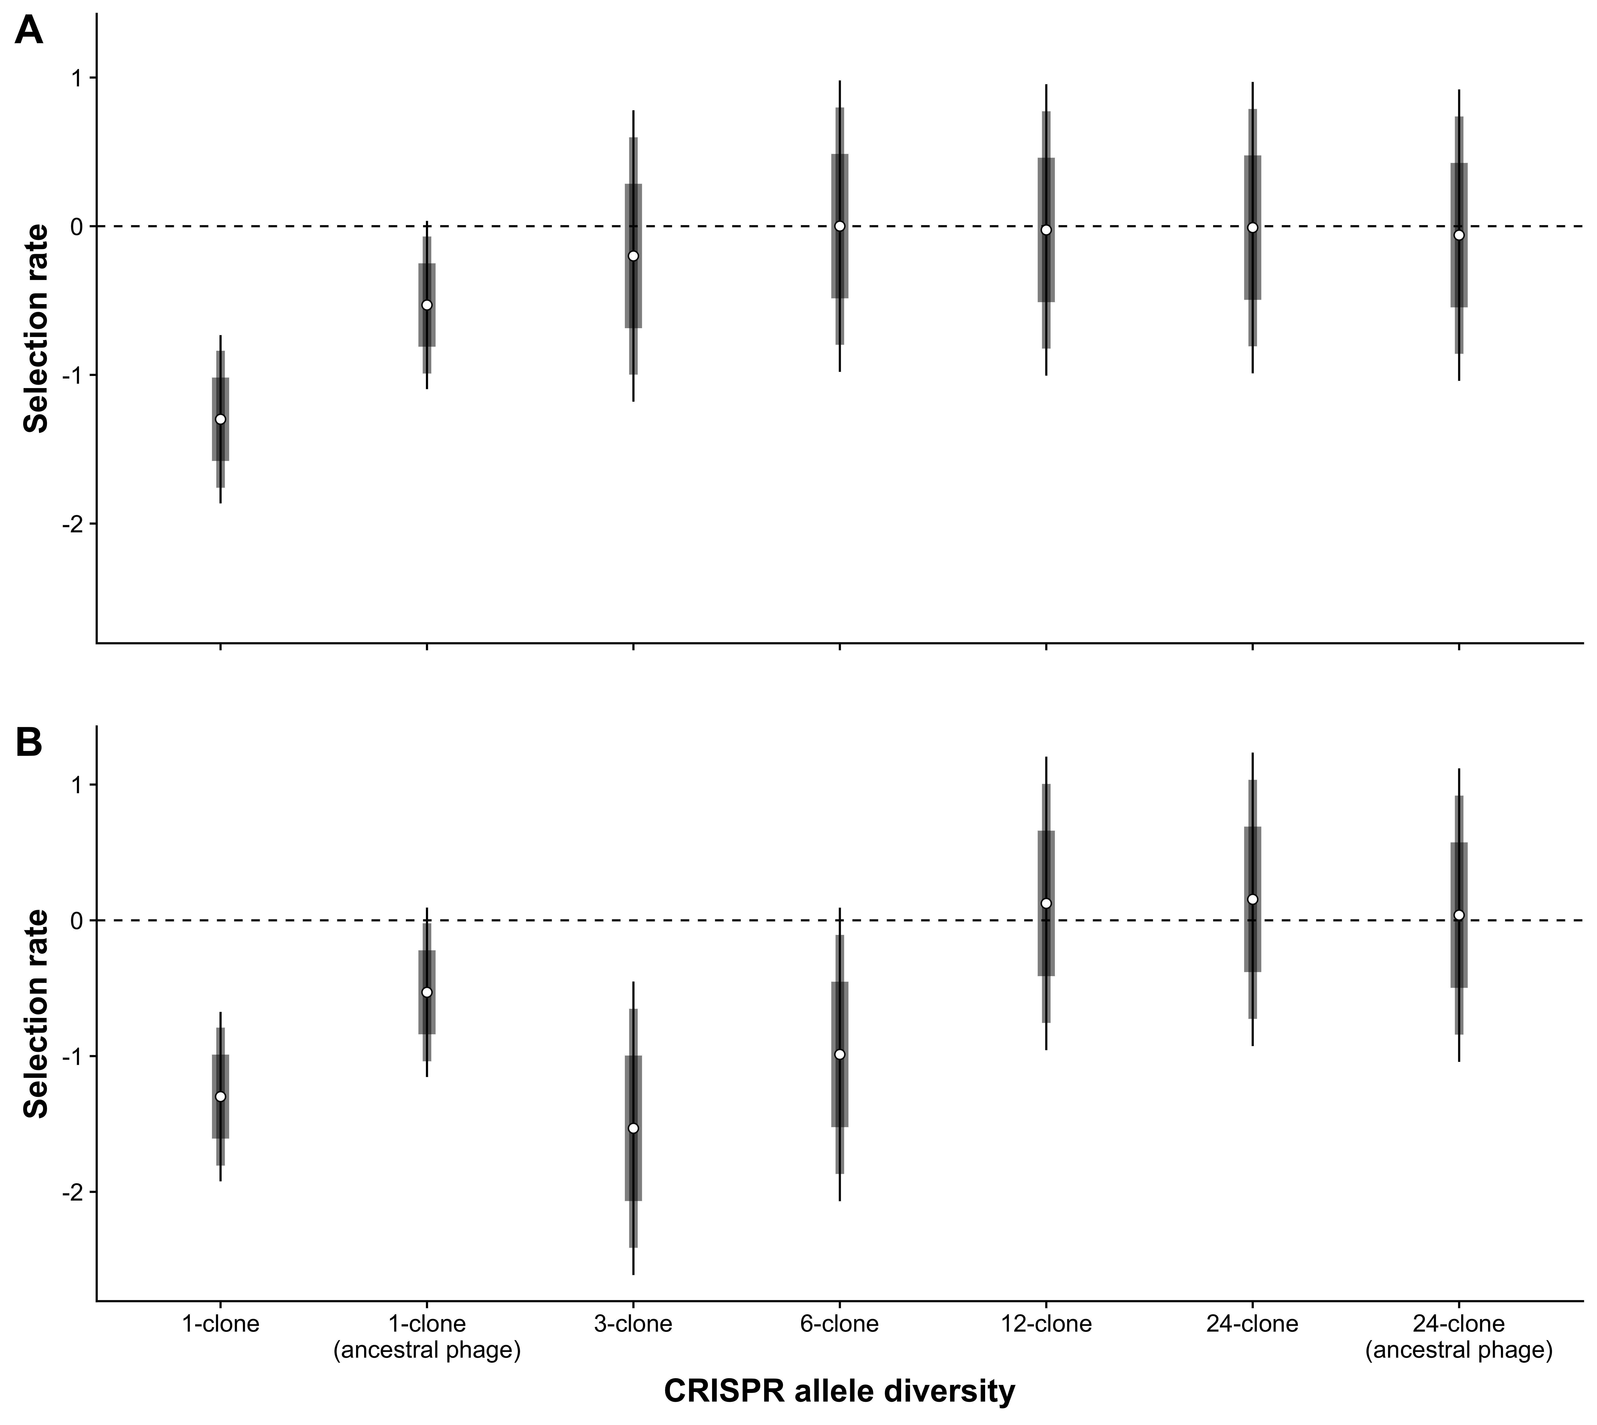

# References

1. O'Brien SJ, Roelke ME, Marker L, Newman A, Winkler C, Meltzer D, et al. Genetic basis for species vulnerability in the cheetah. Science. 1985;227(4693):1428-34.

2. Pearman PB, Garner TW. Susceptibility of Italian agile frog populations to an emerging strain of Ranavirus parallels population genetic diversity. Ecology Letters. 2005;8(4):401-8.

3. Eastwood JR, Ribot RF, Rollins LA, Buchanan KL, Walder K, Bennett AT, et al. Host heterozygosity and genotype rarity affect viral dynamics in an avian subspecies complex. Scientific reports. 2017;7(1):13310.

4. Spielman D, Brook BW, Briscoe DA, Frankham R. Does inbreeding and loss of genetic diversity decrease disease resistance? Conservation Genetics. 2004;5(4):439-48.

5. Ebert D, Altermatt F, Lass S. A short term benefit for outcrossing in a Daphnia metapopulation in relation to parasitism. Journal of the Royal Society Interface. 2007;4(16):777-85.

6. Kerstes NA, Wegner KM. The effect of inbreeding and outcrossing of Tribolium castaneum on resistance to the parasite Nosema whitei. Evolutionary Ecology Research. 2011;13(7):681-96.

7. Ellison AM, Adamec L. Ecophysiological traits of terrestrial and aquatic carnivorous plants: are the costs and benefits the same? Oikos. 2011;120(11):1721-31.

8. Thorne ET, Williams ES. Disease and endangered species: the black‐footed ferret as a recent example. Conservation Biology. 1988;2(1):66-74.

9. Acevedo-Whitehouse K, Gulland F, Greig D, Amos W. Inbreeding: disease susceptibility in California sea lions. Nature. 2003;422(6927):35.

10. Meagher S. Genetic diversity and Capillaria hepatica (Nematoda) prevalence in Michigan deer mouse populations. Evolution. 1999;53(4):1318-24.

11. Whiteman NK, Kimball RT, Parker PG. Co‐phylogeography and comparative population genetics of the threatened Galápagos hawk and three ectoparasite species: ecology shapes population histories within parasite communities. Molecular Ecology. 2007;16(22):4759-73.

12. Elton CS. The ecology of invasions by animals and plants. London: Methuen & Co.; 1958.

13. Zhu Y, Chen H, Fan J, Wang Y. Genetic diversity and disease control in rice. Nature. 2000;406(6797):718.

14. López-Uribe MM, Appler RH, Youngsteadt E, Dunn RR, Frank SD, Tarpy DR. Higher immunocompetence is associated with higher genetic diversity in feral honey bee colonies (Apis mellifera). Conservation Genetics. 2017;18(3):659-66.

15. Altermatt F, Ebert D. Genetic diversity of Daphnia magna populations enhances resistance to parasites. Ecology Letters. 2008;11(9):918-28.

16. Luijckx P, Fienberg H, Duneau D, Ebert D. A Matching-Allele Model Explains Host Resistance to Parasites. Current Biology. 2013.

17. van Houte S, Ekroth AKE, Broniewski JM, Chabas H, Ashby B, Bondy-Denomy J, et al. The diversity-generating benefits of a prokaryotic adaptive immune system. Nature. 2016;532(7599):385-8.

18. Morley D, Broniewski JM, Westra ER, Buckling A, van Houte S. Host diversity limits the evolution of parasite local adaptation. Molecular ecology. 2017;26(7):1756-63.

19. Ostfeld RS, Keesing F. Effects of host diversity on infectious disease. Annual review of ecology, evolution, and systematics. 2012;43.

20. Civitello DJ, Cohen J, Fatima H, Halstead NT, Liriano J, McMahon TA, et al. Biodiversity inhibits parasites: broad evidence for the dilution effect. Proceedings of the National Academy of Sciences. 2015;112(28):8667-71.

21. Lively CM. The Effect of Host Genetic Diversity on Disease Spread. The American Naturalist. 2010;175(6):E149-E52.

22. Dobson A. Population dynamics of pathogens with multiple host species. the american naturalist. 2004;164(S5):S64-S78.

23. Gandon S. Evolution of multihost parasites. Evolution. 2004;58(3):455-69.

24. Dennehy JJ, Friedenberg NA, Yang YW, Turner PE. Virus population extinction via ecological traps. Ecology letters. 2007;10(3):230-40.

25. Common J, Westra ER. CRISPR evolution and bacteriophage persistence in the context of population bottlenecks. RNA Biology. 2019.

26. Ohtsuki A, Sasaki A. Epidemiology and disease-control under gene-for-gene plant–pathogen interaction. Journal of theoretical biology. 2006;238(4):780-94.

27. Sasaki A. Host-parasite coevolution in a multilocus gene-for-gene system. Proceedings of the Royal Society B: Biological Sciences. 2000;267(1458):2183-8.

28. Dennehy JJ, Friedenberg NA, Holt RD, Turner PE. Viral ecology and the maintenance of novel host use. The American Naturalist. 2006;167(3):429-39.

29. Antia R, Regoes RR, Koella JC, Bergstrom CT. The role of evolution in the emergence of infectious diseases. Nature. 2003;426(6967):658.

30. Yates A, Antia R, Regoes RR. How do pathogen evolution and host heterogeneity interact in disease emergence? Proceedings of the Royal Society B: Biological Sciences. 2006;273(1605):3075-83.

31. Chabas H, Lion S, Nicot A, Meaden S, van Houte S, Moineau S, et al. Evolutionary emergence of infectious diseases in heterogeneous host populations. PLOS Biology. 2018;16(9):e2006738.

32. Benmayor R, Hodgson DJ, Perron GG, Buckling A. Host mixing and disease emergence. Current Biology. 2009;19(9):764-7.

33. Westra ER, Sünderhauf D, Landsberger M, Buckling A. Mechanisms and consequences of diversity-generating immune strategies. Nature Reviews Immunology. 2017;17(11):719.

34. Horvath P, Romero DA, Coute-Monvoisin AC, Richards M, Deveau H, Moineau S, et al. Diversity, activity, and evolution of CRISPR loci in *Streptococcus thermophilus*. Journal of Bacteriology. 2008;190(4):1401-12.

35. Brouns SJJ, Jore MM, Lundgren M, Westra ER, Slijkhuis RJH, Snijders APL, et al. Small CRISPR RNAs Guide Antiviral Defense in Prokaryotes. Science. 2008;321(5891):960-4.

36. Garneau JE, Dupuis M-E, Villion M, Romero DA, Barrangou R, Boyaval P, et al. The CRISPR/Cas bacterial immune system cleaves bacteriophage and plasmid DNA. Nature. 2010;468(7320):67-71.

37. Datsenko KA, Pougach K, Tikhonov A, Wanner BL, Severinov K, Semenova E. Molecular memory of prior infections activates the CRISPR/Cas adaptive bacterial immunity system. Nat Commun. 2012;3:945.

38. Marraffini LA, Sontheimer EJ. CRISPR interference limits horizontal gene transfer in staphylococci by targeting DNA. Science. 2008;322(5909):1843-5.

39. Semenova E, Jore MM, Datsenko KA, Semenova A, Westra ER, Wanner B, et al. Interference by clustered regularly interspaced short palindromic repeat (CRISPR) RNA is governed by a seed sequence. Proceedings of the National Academy of Sciences. 2011;108(25):10098-103.

40. Westra ER, Semenova E, Datsenko KA, Jackson RN, Wiedenheft B, Severinov K, et al. Type IE CRISPR-cas systems discriminate target from non-target DNA through base pairing-independent PAM recognition. PLoS genetics. 2013;9(9):e1003742.

41. Mojica FJ, Diez-Villasenor C, Garcia-Martinez J, Almendros C. Short motif sequences determine the targets of the prokaryotic CRISPR defence system. Microbiology. 2009;155(Pt 3):733-40.

42. Deveau H, Barrangou R, Garneau JE, Labonté J, Fremaux C, Boyaval P, et al. Phage Response to CRISPR-Encoded Resistance in *Streptococcus thermophilus*. Journal of Bacteriology. 2008;190(4):1390-400.

43. Common J, Morley D, van Houte S, Westra ER. CRISPR-Cas immunity leads to a coevolutionary arms race between *Streptococcus* *thermophilus* and lytic phage. Philosophical Transactions of the Royal Society B: Biological Sciences. 2019.

44. Paez-Espino D, Morovic W, Sun CL, Thomas BC, Ueda K-i, Stahl B, et al. Strong bias in the bacterial CRISPR elements that confer immunity to phage. Nature communications. 2013;4:1430.

45. Paez-Espino D, Sharon I, Morovic W, Stahl B, Thomas BC, Barrangou R, et al. CRISPR immunity drives rapid phage genome evolution in Streptococcus thermophilus. MBio. 2015;6(2).

46. Sun CL, Thomas BC, Barrangou R, Banfield JF. Metagenomic reconstructions of bacterial CRISPR loci constrain population histories. ISME J. 2016;10(4):858-70.

47. Andersson AF, Banfield JF. Virus population dynamics and acquired virus resistance in natural microbial communities. Science. 2008;320(5879):1047-50.

48. Westra ER, van Houte S, Oyesiku-Blakemore S, Makin B, Broniewski Jenny M, Best A, et al. Parasite Exposure Drives Selective Evolution of Constitutive versus Inducible Defense. Current Biology. 2015;25(8):1043-9.

49. Lenski RE, Levin BR. Constraints on the coevolution of bacteria and virulent phage: a model, some experiments, and predictions for natural communities. The American Naturalist. 1985;125(4):585-602.

50. Levin BR, Moineau S, Bushman M, Barrangou R. The population and evolutionary dynamics of phage and bacteria with CRISPR–mediated immunity. PLoS genetics. 2013;9(3):e1003312.

51. Chabas H, Lion S, Nicot A, Meaden S, van Houte S, Moineau S, et al. Evolutionary emergence of infectious diseases in heterogeneous host populations. bioRxiv. 2018:317099.

52. van Houte S, Ekroth AK, Broniewski JM, Chabas H, Ashby B, Bondy-Denomy J, et al. The diversity-generating benefits of a prokaryotic adaptive immune system. Nature. 2016;532(7599):385.

53. Agrawal A, Lively CM. Infection genetics: gene-for-gene versus matching-alleles models and all points in between. Evolutionary Ecology Research. 2002;4(1):79-90.

54. Lively CM, Roode JCd, Duffy MA, Graham AL, Koskella B. Interesting Open Questions in Disease Ecology and Evolution. The American Naturalist. 2014;184(S1):S1-S8.

55. Lenski RE. Quantifying fitness and gene stability in microorganisms. Biotechnology. 1991;15:173-92.

56. Travisano M, Lenski RE. Long-term experimental evolution in Escherichia coli. IV. Targets of selection and the specificity of adaptation. Genetics. 1996;143(1):15-26.

57. Keesing F, Holt RD, Ostfeld RS. Effects of species diversity on disease risk. Ecology letters. 2006;9(4):485-98.

58. King KC, Delph LF, Jokela J, Lively CM. Coevolutionary hotspots and coldspots for host sex and parasite local adaptation in a snail–trematode interaction. Oikos. 2011;120(9):1335-40.

59. Pachepsky E, Crawford JW, Bown JL, Squire G. Towards a general theory of biodiversity. Nature. 2001;410(6831):923.

60. McGill BJ, Etienne RS, Gray JS, Alonso D, Anderson MJ, Benecha HK, et al. Species abundance distributions: moving beyond single prediction theories to integration within an ecological framework. Ecol Lett. 2007;10(10):995-1015.

61. Hudson PJ, Dobson AP, Lafferty KD. Is a healthy ecosystem one that is rich in parasites? Trends Ecol Evol. 2006;21(7):381-5.

62. Telfer S, Lambin X, Birtles R, Beldomenico P, Burthe S, Paterson S, et al. Species interactions in a parasite community drive infection risk in a wildlife population. Science. 2010;330(6001):243-6.

63. Ganz HH, Ebert D. Benefits of host genetic diversity for resistance to infection depend on parasite diversity. Ecology. 2010;91(5):1263-8.

64. Zegans ME, Wagner JC, Cady KC, Murphy DM, Hammond JH, O'Toole GA. Interaction between bacteriophage DMS3 and host CRISPR region inhibits group behaviors of *Pseudomonas aeruginosa*. Journal of Bacteriology. 2009;191(1):210-9.

65. Cady KC, Bondy-Denomy J, Heussler GE, Davidson AR, O'Toole GA. The CRISPR/Cas Adaptive Immune System of *Pseudomonas aeruginosa* Mediates Resistance to Naturally Occurring and Engineered Phages. Journal of Bacteriology. 2012;194(21):5728-38.

66. Ferrieres L, Hémery G, Nham T, Guérout A-M, Mazel D, Beloin C, et al. Silent mischief: bacteriophage Mu insertions contaminate products of *Escherichia coli* random mutagenesis performed using suicidal transposon delivery plasmids mobilized by broad-host-range RP4 conjugative machinery. Journal of Bacteriology. 2010;192(24):6418-27.

67. Kearse M, Moir R, Wilson A, Stones-Havas S, Cheung M, Sturrock S, et al. Geneious Basic: an integrated and extendable desktop software platform for the organization and analysis of sequence data. Bioinformatics. 2012;28(12):1647-9.

68. Martínez-García E, Aparicio T, de Lorenzo V, Nikel PI. New transposon tools tailored for metabolic engineering of Gram-negative microbial cell factories. Frontiers in Bioengineering and Biotechnology. 2014;2:46.

69. R Core Team. R: A language and environment for statistical computing. 3.5.2 "Eggshell Igloo" ed. Vienna, Austria: R Foundation for Statistical Computing; 2018.

70. Wickham H, François R, Henry L, Mûller K. dplyr: A Grammar of Data Manipulation. 0.7.8 ed2018.

71. Henry L, Wickham H. tidyr: Easily Tidy Data with 'spread()' and 'gather()' Functions. 2018.

72. Bache SM, Wickham H. magrittr: A Forward-Pipe Operator for R. 1.5 ed2014.

73. Burnham KP, Anderson DR. Multimodel inference: understanding AIC and BIC in model selection. Sociol Methods Res. 2004;33(2):261-304.

74. Burnham KP, Anderson DR. Model selection and multimodel inference: a practical information-theoretic approach. New York: Springer; 2003.

75. Hadfield JD. MCMC Methods for Multi-Response Generalized Linear Mixed Models: The MCMCglmm R Package. Journal of Statistical Software. 2010;33(2):1-22.

76. Brown M. VCVglmm: Manipulating model outputs from MCMCglmm and lme4 objects, usually involving variance-covariance matrices. 0.0.0.9 ed2019.

77. Wickham H. ggplot2: Elegant Graphics for Data Analysis. Springer-Verlag New York; 2009.